Lab-3

**Build an Android application that provides the following features**

Creating an android application for generating a text file (Sensor_sovd6.txt) on mobile device which is then saved onto our system.

Open Eclipse import the project, resolve issues if any, then run the application as android application choosing the connected android device.

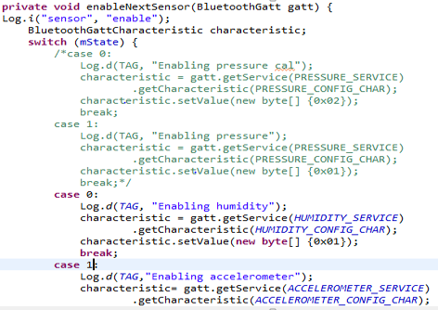

I have chosen humidity accelerometer date and geo co-ordinates for collecting data from sensor device. Running the application generates a text file which looks to the below screen shot

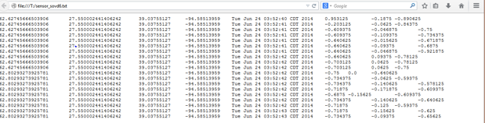

Save the file onto your local device. My saved copy of the text file is as below.



**HBase CRUD operations (Create, Retrieve, Update, Delete) (Using Web Services)**

Install juno eclipse, unzip it then open the eclipse.exe, now open javaee perspective and choose the server tab. Right click the tab open new server and install the glassfish as shown in the class.

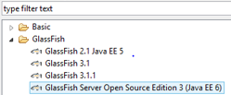

Below is the view after importing the project into the workbench, without any errors as they would appear. That is due to the missing library of java standard. Add it and clean the project fortunately there would not be any errors.

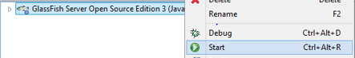

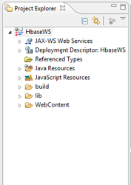 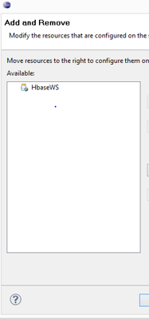

Above are the screen shots of project and left is that which appears after starting the server.

Next to that is console windows, it displays following information.

Waiting for DAS to start….

Started domain: domain2

Domain location: C:\Users\Sujitha\glassfishv3\glassfish\domains\domain2

Log file: C:\Users\Sujitha\glassfishv3\glassfish\domains\domain2\logs\server.log

Admin port for the domain: 4848

Command start-domain executed successfully.

Now right click the project run --- run on server. It must display the “hello World screen”, implying everything so far is well and good.

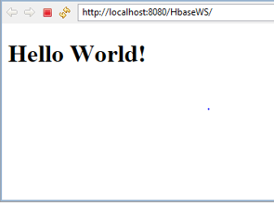

Next pivotal thing is operations. Trying the creation and deletion of table is as follows.

